1. What are Partitioning Operators in LINQ?

The LINQ Partitioning Operators in C# are used to divide a sequence, or you can say data source, into two parts and then return one of them as output without changing the positions of the elements.

1. Why do we need Partitioning Operators in C#?

LINQ (Language Integrated Query) provides a set of partitioning operators in C# that allow you to divide a sequence into smaller parts or retrieve elements from specific positions within a sequence. These partitioning operators are helpful when you need to work with subsets of data or extract elements from specific positions in a collection. We need to use Partitioning operators when we want to perform the following operations.

* When selecting the top n number of records from a data source.
* If you want to select records from a data source until a specified condition is true.
* When selecting records from a data source except for the first n number of records.
* If we want to skip records from a data source until a specified condition is true, select all remaining records from the data source.
* It can be used to implement pagination for a data source.

1. Partitioning Methods Provided by LINQ:

LINQ partitioning operators in C# are used to divide the input sequence into two parts and then return one of the parts. These operators make it easy to take or skip elements from a sequence. LINQ provides the following four methods to perform Partitioning Operations

* **Take**: This operator selects the first n elements from a sequence. If the sequence contains fewer than n elements, it returns all the available elements. For example, var firstThree = numbers.Take(3); // Takes the first three elements
* **TakeWhile**: It returns elements from the start of a sequence as long as a specified condition is true. Once an element fails the condition, the method stops. For example, var takenWhile = numbers.TakeWhile(n => n < 4); // Takes numbers less than 4
* **Skip**: This operator bypasses a specified number of elements in a sequence and then returns the remaining elements. For example, var allButFirstThree = numbers.Skip(3); // Skips the first three elements
* **SkipWhile**: It bypasses elements in a sequence as long as a specified condition is true and then returns the remaining elements. For example, var skippedWhile = numbers.SkipWhile(n => n < 4); // Skips numbers less than 4

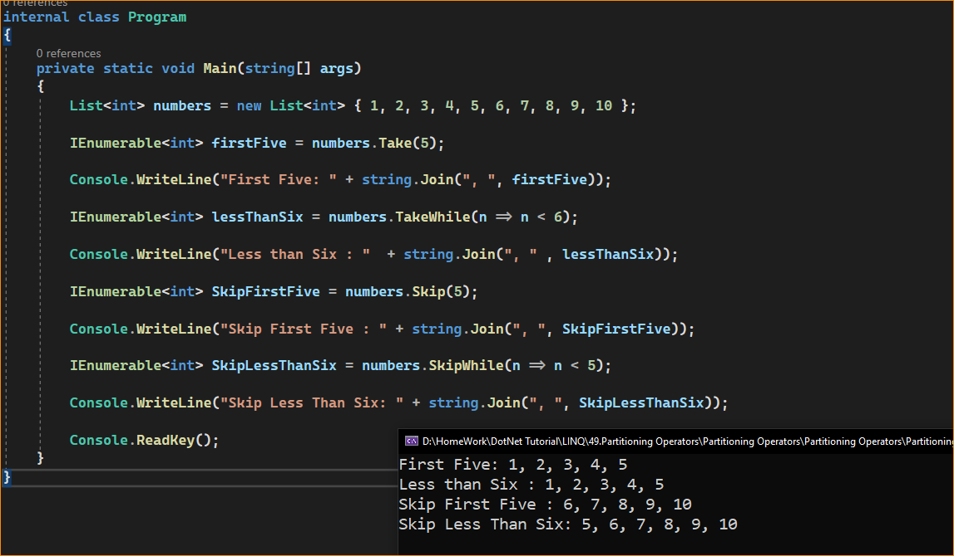

When to use LINQ Partitioning Operators in C#?

LINQ partitioning operators in C#, such as Take, Skip, TakeWhile, SkipWhile, TakeLast, and SkipLast, are useful in various scenarios when you need to work with specific subsets of data or extract elements from specific positions within a collection. Here are some common scenarios when you should consider using LINQ partitioning operators:

* Paging: When implementing pagination in a user interface, you might use Take to display a specific number of items on each page and Skip to bypass the number of items displayed on all previous pages.
* Top N or Bottom N Records: When you want to retrieve the top N records with the highest values or the bottom N records with the lowest values from a sorted dataset, you can use Take and TakeLast.
* Performance Optimization: When working with a small subset of a large collection, using Take or Skip can help minimize the workload by only processing the required elements.
* Conditional Retrieval: TakeWhile and SkipWhile are useful when you need elements up to the point where a condition is met. For instance, in a list of sorted dates, you might want to take all dates until the end of the current year.
* Data Sampling: If you want to sample a fixed number of items from a dataset, perhaps for testing or analysis, Take can be used to extract just those items easily.
* Streaming Data: When dealing with streaming data or large datasets where you do not want to or cannot load all the data into memory at once, partitioning operators allow you to work with the data in chunks.
* Sequential Processing: In scenarios where data must be processed in a certain sequence until a condition changes (like errors in a log file), TakeWhile and SkipWhile can process only the relevant sections.
* Resource Management: When dealing with resources that need to be used sparingly (like API calls that have rate limits), partitioning operators can help manage how much data you are processing at a time.

LINQ partitioning operators are valuable tools when working with specific data portions within a collection. They help you retrieve, manipulate, and display data efficiently, especially when dealing with large datasets or implementing features like data paging and filtering in your applications.